**Project Design Phase-II**

**Data Flow Diagram & User Stories**

|  |  |
| --- | --- |
| Date | 03 October 2022 |
| Team ID | PNT2022TMID52627 |
| Project Name | Project – Smart Farmer- Iot enabled Smart Farming Application |
| Maximum Marks | 4 Marks |

**SMART FARMING APPLICATION -Data Flow Diagrams:**

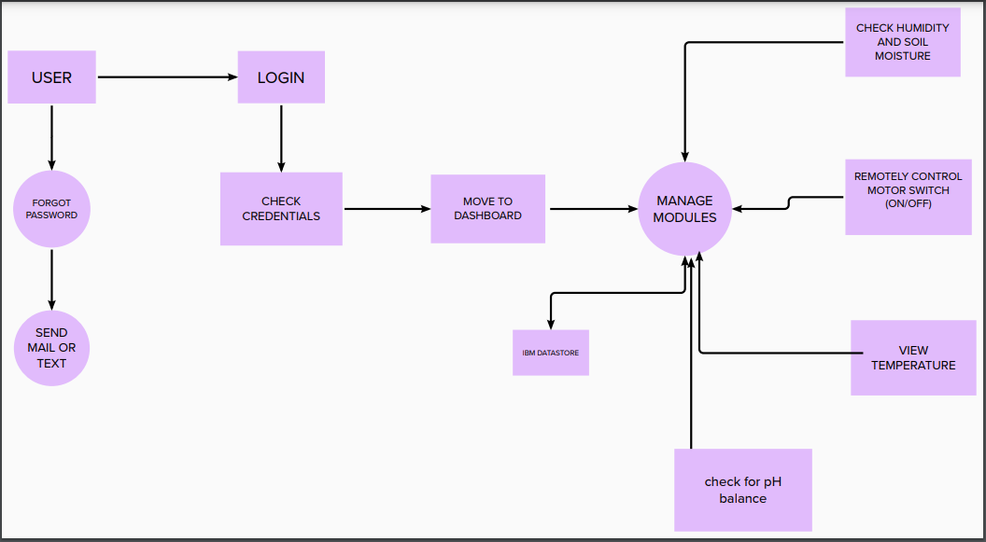

USER STORIES:

